Overview

• Preliminaries (Ch 1) • Solving nonlinear equation (Ch 3) • Interpolation (Ch 4) • Integration (Ch 5)

• Solving linear system (Ch 2+8) • Initial value problem (Ch 7)

Nonlinear equations

• Root-finding problem: find x s.t. f(x)=0

• Methods to be studied – Bisection method (3.1) – Newton’s method (3.2) – Secant method (3.3)

• Convergence analysis • Comparison and discussions

Interpolation (Phép nội suy)

. A special case: super-resolution

• Polynomial interpolation

• Error analysis

• Data fitting → machine learning

• Riemann sum

• Methods to be studied – Trapezoid method (5.1)

– Simpson’s rules (5.3) – Gaussian Quadrature formula (5.4)

• Error analysis

Solving Ax = b

• Gaussian elimination (2.1) • Pivoting (2.2) • Tridiagonal and banded system (2.3)

• Matrix factorization (8.1) • Singular Value Decomposition (8.2) • Power method (8.3) • Iterative method (8.4)

Initial value problem

Do you have ODE background?

• Methods – Taylor series method (7.1) – Runge-Kutta method (7.2)

**Chapter 1.1: MATHEMATICAL PRELIMINARIES**

Significant digits of precision

• Non-zero digits within given measurements are significant.

• **Zeros to the right of the last non-zero digit are significant if within the measurement**.

• Zeros to the left of the first nonzero digit are NOT significant.

• An exact number has an infinite number of significant digits (or figures).

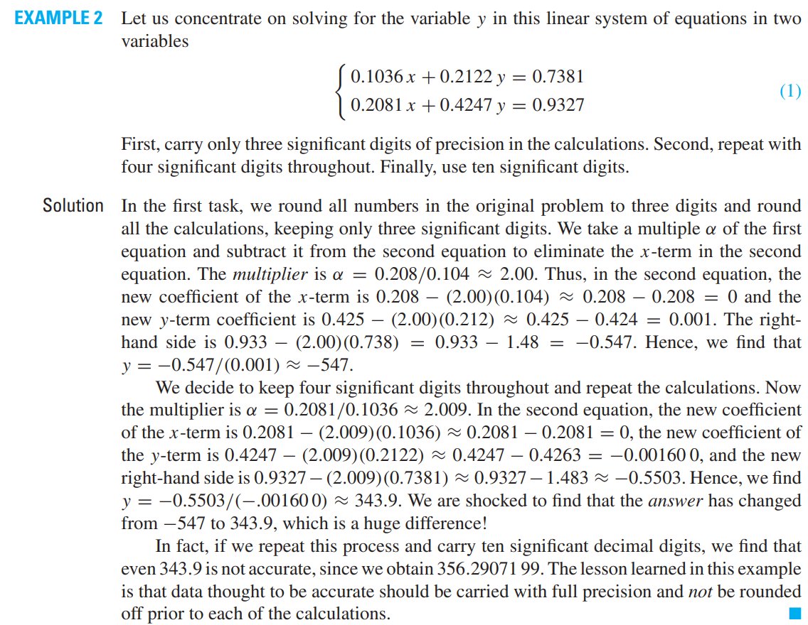

. Data thought to be accurate should be carried with full precision and not be rounded prior to each of the calculation.

Errors

• In computing **absolute error**, the roles of these two values are the same, whereas in relative errors it is essential to distinguish the correct one.

• In practice, relative error is more meaningful. Sometimes, **percentage error** is used.

• The **exact value** may be the **true value** or the **best-known value**.

Rounding and chopping

• Rounding reduces the number of significant digits in a number.

• The result of rounding is a number similar in magnitude that is a shorter number having fewer nonzero digits.

• The round-to-even rule tends to reduce the total rounding error with (on average) an equal portion of numbers rounding up and down.

• Compared to chopping, rounding is preferrable.

Nested multiplication

. To evaluate the polynomial



. we group the terms in a nested multiplication:



**The pseudocode** that evaluates p(x) starts with the innermost parentheses and works out-ward. It can be written as

**integer** i, n; real p, x; **real array** (ai)0:n

p ← an

**for** i = n − 1 **to** 0 **do** p ← ai + x*p

**end for**

Review theoretical tools for numerical analysis:

• Taylor series/Theorem • Ratio test • Alternating

Theorem Computational tools:

• Horner’s algorithm

Taylor series

Use Taylor for computation

• Use the Taylor series for the natural logarithm

• With 𝑥 = 1

• Add the eight terms

Alternative

• Use a different Taylor series

• With 𝑥 = 1/3

• Add the four terms and multiply by 2

Take-home message

Fast convergence of a Taylor series can be expected near the point of expansion.

• Taylor series for 𝑓(𝑥) at a point c

• Maclaurin series if 𝑐 = 0.

• How to compute? Horner’s algorithm.

Deflation (Giảm phát)

Given a polynomial



Horner’s algorithm can be used in the deflation of a polynomial. This is the process of removing a linear factor from a polynomial. If r is a root of the polynomial p, then x − r is a factor of p. The remaining roots of p are the n − 1 roots of a polynomial q of degree 1 less than the degree of p such that

**and a number 𝑟 find another polynomial s.t.**



Where: 

• A special case of polynomial long division.

• If 𝑝 (𝑟) = 0, 𝑟 is a root of the polynomial.

The pseudocode for Horner’s algorithm can be written as follows:

**integer** i, n; real p,r; **real array** (ai)0:n, (bi)0:n−1

bn−1 ← an

**for** i = n − 1 **to** 0 **do** bi−1 ← ai + rbi

**end for**

Back to Taylor expansion

• Recall:

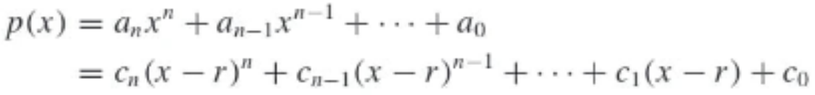

• Deflating the polynomial



• Pseudocode

Taylor Theorem

• In practice, it is necessary to truncate→partial sum.

• E is called the remainder or error term.

• Convergence can be established in some cases.

Mean Value Theorem

A special case of Taylor Theorem

Taylor Theorem for 𝑓(𝑥 + ℎ)

• Error term converges to zero with the same rate as ℎ𝑛𝑛+1.

Examples

• It holds for every n

• Some commonly used ones:

Alternating series

• It only applies to alternating series.

• It gives an upper bound for the error.

• Back to ln 2 for an example.

**Recap on Taylor**

• Error term converges to zero with the same rate as ℎ𝑛𝑛+1.

Examples

• It holds for every n

• Some commonly used ones:

Today’s Overview

• Computers usually do not use base-10 numbers.

• Numbers that have a finite expression in one number system may have an infinite one in

another, e.g. 

• We will discuss

– Floating-point number system

– Roundoff error

Floating-point (FP) Repre

For example, 37.2345, 0.0003541, -3093453.32

• **Decimal form** – Integer part – A decimal point – Fractional part

• Normalized scientific notation: leading digit in the fraction is NOT zero.

– e.g., 37.2345 = 0.372345 × 102

• (Standard) scientific notation:

– e.g., 2.99 × 108 m/s

Normalized FP Repre.

Normalized floating-point representation: 𝑥 = ±𝑟 × 10𝑛

• A sign that is either + or –

• A number 𝑟 ∈ [ 1 /10 , 1)

– called **normalized mantissa**

• An **integer power** of 10

– 𝑛 is called exponent.

Binary system

• If 𝑥 ≠ 0, it can be written as 𝑥 = ±𝑞 × 2𝑚 ( 1/ 2 ≤ 𝑞 < 1)

• The mantissa would be expressed a sequence of binary values (0 or 1) 𝑞 = (0. 𝑏1𝑏2𝑏3 ⋯)2

• 𝑏1 ≠ 0 → 𝑏1 = 1 → 𝑞 ≥ 1/ 2 .

• Next example: list all the numbers can be expressed as and 𝑘 = 0 or 1.

Example 1

Computer number system

• Every computer can only represent a **finite** number of digits.

• The real numbers that are representable in a computer are called its **machine number**.

• **Overflow/underflow** describe something is too big/small.

• An **overflow** often results in a fatal error.

• An **underflow** is usually treated automatically by setting to zero with a warning message.

Common levels of precision

Single precision

• Recall 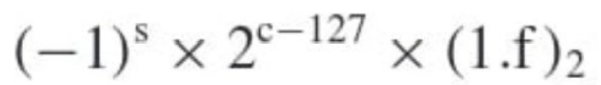

• 0 < 𝑐 < ( 11 111 111) 2 = 255 ⇒ −127 < 𝑐 − 127 < 128

• 1 ≤ (1. 𝑓)2 = 2 − 2−23

• Largest machine number: 3.4 × 1038

• Smallest machine number: 1.2 × 10−38

• **Machine epsilon**: smallest number 1 + 𝜖 ≠ 1

* 𝜖 = 2−24 ≈ 6 × 10−8 ⇒ **7 significant decimal digits**

Example 2 Determine -52.234375 in single precision.

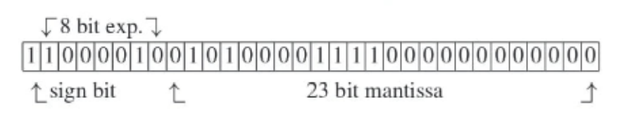

Double precision

• 11 bits for exponent and 52 for mantissa

• Largest machine number: 1.8 × 10308

• Smallest machine number: 2.2 × 10−308

• Machine epsilon: 2−53 ≈ 1.11 × 10−16

– **15 significant decimal digits**

Computer errors

• The process of replacing a number by its nearest machine number is called **correct rounding**; the error involved is called **roundoff error**.

• If a number is **overflow or underflow**, **roundoff** error could be huge.

FP machine number

• Define fl(x) be the FL machine number that corresponds to x

• The function fl depend on the computer.

•For a 32-bit word length computer, we have

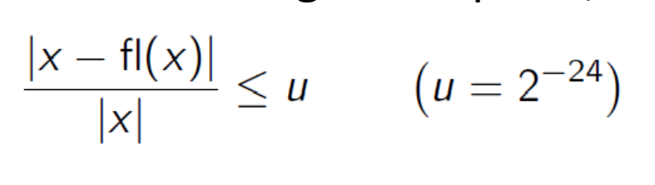

• The inequality can be expressed by

Rounding

• Suppose



• Round down

• Round up

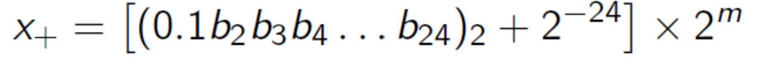

Unit roundoff error

The **unit roundoff error** for a 32 bit binary computer is 𝑢 = 2−24 , which is equivalent to **machine epsilon**.

Errors in arithmetic operations

Example

• Suppose we have a five-place decimal machine and have two numbers to add



• Perform operations in double-length

• Error involved

FP machine number

• Define fl(x) be the FL machine number that corresponds to x

• The function fl depend on the computer.

•For a 32-bit word length computer, we have



• The inequality can be expressed by

Arithmetic operations



Example: If x, y are real numbers in a 32-bit computer, estimate the relative roundoff error in computing (x+y).

Loss of Significance

• Significance of the digits diminishes from left to right.

• Every measured quantity involves an error whose magnitude depends on the nature of the measuring device.

• If a meter stick is used, it is not reasonable to get precision better than 1 millimeter, e.g., 2.3453 meters.

• The least significant digit should be in error by at most 5 units, i.e., measured result is **rounded correctly**.

Infinite precision

• If the side of a square is reported to be s = 0.736 meter, then error does not exceed 5 units in the third decimal place.

• The diagonal of the square 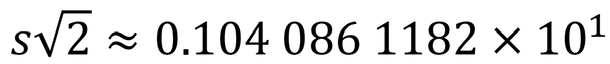

should be reported as 0.1041 × 101.

than was already present in 𝑠.

Loss of significance

Loss of significance

• Consider to execute the statement at x=1/15

• Then

• Correct value

Theorem on loss of precision

**Exact how much significant binary digits are lost in subtraction x-y when x is close to y**?

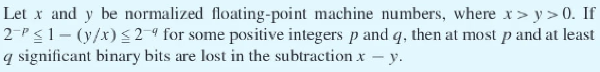

• The closeness of x and y is measured by |1 – 𝑦/ 𝑥 |.

• Double precision may help.

• Taylor series may help

Avoid loss of significance

• Double precision • Taylor series • Rationalization • Trigonometric identities • Logarithmic properties • Range reduction

Root finding

. A number 𝑟 (real or complex), for which 𝑓(𝑟)=0 is called a **root** or a **zero** of 𝑓.

. Why is locating roots important?

. How to find a root?

* Closed-form solution
* Bisection method

Intermediate Value Theorem (IVT)

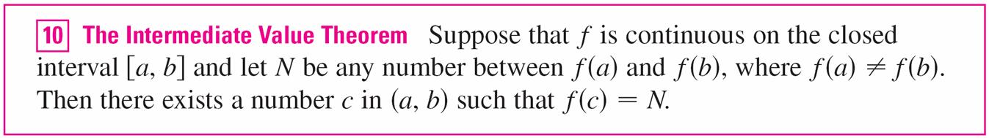

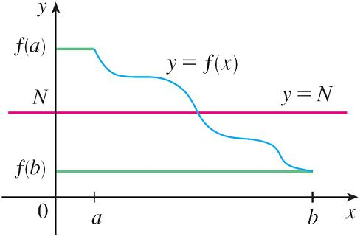

Bisection method

* Find a root of **a continuous** function $f(x)$.
* At each step, we have an interval $\left[a,b\right]$ with $u=f\left(a\right), v=f\left(b\right), uv<0$.
* Midpoint $c=\frac{1}{2}(a+b)$ and $w=f\left(c\right).$
* If $w=0,$**great**!
* Else either $wu<0$ or $wv<0.$**why**?
* If $wu<0,$ then a root exists in $\left[a,c\right];$ we store the value of $c$ **in $b$**  and $w$ **in $v$** .
* If $wv<0,$ then a root exists in $\left[c,b\right];$ we store the value of $c$**in $a$**  and $w$ **in $u$** .
* In either case, we get to the beginning except that the interval is half as large as the initial one.
* When to stop: interval is sufficiently small, e.g., $\left|b-a\right|<{10}^{-6}.$
* What’s the final output: $\frac{a+b}{2}.$

Pseudocode

* Input: $f\left(x\right), [a, b]$ (initial interval)
* Output: $r$ satisfies $f\left(r\right)=0$

**Remarks**

* Any function value that may be needed later should be stored rather than recomputed.
* Always have stopping conditions in place to avoid **endless** loops.
* Avoid using **== and ~=**
* Underflow/overflow may arise.
* Trace the steps in routine to see it does what is claimed.

Numerical examples

**Convergence analysis**

**Analysis**

* Suppose that $f$ is a continuous function that takes values of opposite sign at $a_{0}, b_{0}.$
* Then there exists a root $r∈(a_{0,}b_{0})$ by IVT.
* If we use the midpoint as an estimate of $r$, we have 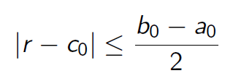

Convergence Theorem

* If error tolerance is prescribed, the number of steps can be calculated.
* The root sought by bisection depends on initial interval and the solution may not be unique.
* Often the bisection method is used to get close to the root before switching to a faster one.

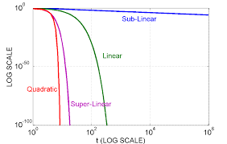Convergence rate

* Linear convergence: $C∈[0,1)$
$$\left|x_{n+1}-x^{*}\right|≤C|x_{n}-x^{*}|$$

* Super linear convergence: $α∈(1,2)$
$$\left|x_{n+1}-x^{*}\right|≤C{\left|x_{n}-x^{*}\right|}^{α}$$

* Quadratic convergence

$$\left|x_{n+1}-x^{*}\right|≤C{\left|x_{n}-x^{*}\right|}^{2}$$

Convergence rate (cont’d)

* A consequence of linear convergence
$$\left|x_{n+1}-x^{*}\right|≤C|x_{n}-x^{*}|$$

$$⇒\left|x_{n+1}-x^{*}\right|≤AC^{n}$$

* Bisection does NOT converge linearly.
* Quadratic convergence doubles the significant digits.

**Bisection variants**

False position method

Rather than selecting the midpoint, this method uses the point where the secant lines intersect the x-axis.

Remarks

* False position method uses the values of $f\left(a\right), f\left(b\right),$ which is more adaptive to a particular function.
* It may repeatedly select the same endpoint.
* Modified false position method changes the slope of the straight line to get closer to the root. In some cases, super linear convergence rate can be obtained.

**Recap on Bisection**

Bisection method for root finding

• “**Almost**” linear convergence:

• Today’s agenda

– Bisection variants

– Matlab tutorial

– Newton’s method

**Bisection variants**

False position method

. Rather than selecting the midpoint, this method uses the point where the secant lines intersect the x-axis.

Remarks

• False position method uses the values of 𝑓(𝑎) , 𝑓(𝑏) , which is more adaptive to a particular function.

• It may repeatedly select the same endpoint.

• Modified false position method changes the slope of the straight line to get closer to the root.

MFP method

Convergence rate

* Linear convergence: $C∈[0,1)$
$$\left|x_{n+1}-x^{*}\right|≤C|x_{n}-x^{*}|$$

* Superlinear convergence: $α∈(1,2)$
$$\left|x_{n+1}-x^{*}\right|≤C{\left|x_{n}-x^{*}\right|}^{α}$$

* Quadratic convergence

$$\left|x_{n+1}-x^{*}\right|≤C{\left|x_{n}-x^{*}\right|}^{2}$$

**Matlab tutorial**

Some facts

• Everything in Matlab is a matrix or tensor!

• Matlab does not need any variable declarations, no dimension statements, no storage allocation, no pointers; but better to aware of these for efficiency.

• Programs can be run step by step, with full access to all variables, functions, etc.

Getting help

• To get help on a function type “help function_name”, e.g., “help plot”.

• To find a topic, type “lookfor topic”, e.g., “lookfor matrix”

**Matlab’s Workspace**

• **who, whos** – current workspace vars.

• **save** – save workspace vars to *.mat file.

• **load** – load variables from *.mat file.

• **clear all** – clear workspace vars.

• **close all** – close all figures

• **clc** – clear screen

• **clf** – clear figure

Variables

• Variable names:

– Must start with a letter

– May contain only letters, digits, and ‘_’

– Case sensitive, one & ONE are different

– Built-in variables/functions are all lower-case.

• Assignment:

– Variable = number

– Variable = expression

Basic Commands

• **%** used to denote a comment

• **;** suppresses display of value (when placed at end of a statement)

• **...** continues the statement on next line

• **eps** machine epsilon

• **inf** infinity

• **NaN** not-a number, e.g., 0/0.

**Numbers**

• To change format of numbers: format long, format short, etc. See “**help format**”.

• Mathematical functions: **sqrt(x), exp(x), cos(x), sin(x), sum(x),** etc.

• Operations: **+, -, * , /,^**

• Constants: **pi, exp(1),** etc.

• Elementwise operator for vectors, .

Arrays and Matrices

• **v = [-2 3 0 4.5 -1.5];** % length 5 row vector.

**• v = v’;** % transposes v.

• **v(1);** % first element of v.

**• v(2:4);** % entries 2-4 of v.

**• v([3,5]);** % returns entries 3 & 5.

• **v=[4:-1:2];** % same as v=[4 3 2];

• **a=1:3; b=2:3; c=[a b];** -> c = [1 2 3 2 3];

. Tic

. Toc

. function handle

**Newton’s method**

Overview

• **Newton’**s method is also called **Newton-Raphson** iteration.

• It has a wider spectrum of applications.

• It requires the function to be differentiable.

• Its basic idea is that the graph at a certain point can be well approximated by its tangent.

Interpretation

• Starting from a point (𝑥0, 𝑓(𝑥0 ))

• Compute the tangent line

• Advance to the next point

Another interpretation

• What correction ℎ should be added to 𝑥𝑥0 to obtain the root precisely?

• Taylor series

O = f(x0) + f’(x0)(x1-x0)

• Find an approximated value for ℎ

Summary of Newton

• Newton’s method returns a sequence of points: 𝑥0, 𝑥1, ⋯

• Recursive or inductive definition: 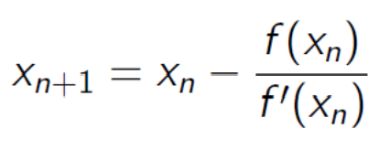

Recap on Newton’s method

• Newton’s recursive definition

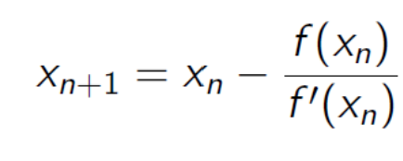

• Today’s agenda – Pseudocode of Newton – Quadratic Convergence – Secant method.

Pseudocode

• Input: f(x), df(x), x0 (initial)

• Output: root of f(x)

Example

• Given

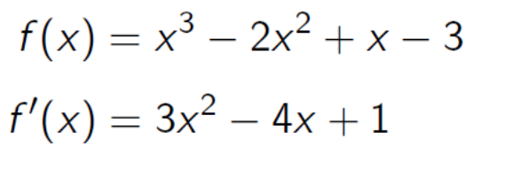

• For efficiency, nested multiplication

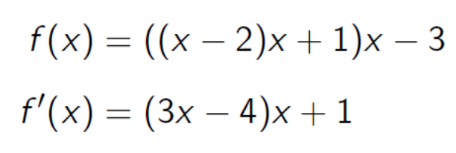

Example (cont’d)

• Doubling of the accuracy in f(x)

• Rapid convergence!

• 5-10 iterations are generally sufficient.

Convergence analysis

If 𝑓, 𝑓′ , 𝑓′′ are continuous in a neighborhood of a root 𝑟 of 𝑓 and if 𝑓′ (𝑟) ≠ 0 (**simple zero**) , then Newton’s method **converges quadratically**! Recall Taylor Theorem

Define

Remarks

• Newton’s method relies on a starting point.

• Bisection (initial) + Newton (improve accuracy)

• Convergence depends upon hypotheses that are difficult to verify a priori.

Failure of Newton’s

Multiplicity

• Quadratic convergence holds only for simple zero, i.e., 𝑓′ (𝑟) ≠ 0

• The multiplicity of the zero is the least 𝑚𝑚 s.t. 𝑓(𝑘)( 𝑟) = 0, ∀𝑘 < 𝑚𝑚

• Newton’s method converges linearly for a multiple zero.

• Modified Newton’s method with multiplicity

Nonlinear equations

Newton’s Method:

An example

**Secant method**

Overview

• **Bisection method** requires two points with opposite signs.

• **Newton method’s** drawback lies in the derivative calculation.

• **Secant method** approximates the function derivative by secant line.

**Remarks**

• Newton’s method could be called tangent method.

• Secant method requires two initial points, but no need to have opposite signs as bisection.

• Overflow may occur if demon is closer to 0.

• Super linear convergence!